LOFAR Specification and Scheduling redesign
for Responsive Telescope

Version 0.2
initial discussion document
By Adriaan Renting

Table of Contents
1 Introduction 4
1.1 Scope 4
1.2 Justification 4
2 Process Model 5
2.1 Specification and Assessment 5
2.2 Planning and Scheduling 6
3 Current implementation 8
3.1 Problems with the current implementation 9
4 Redesign 10
4.1 Implementation phases 10
4.2 Design 11
4.3 Specification Templates 12
4.4 System Specifications 12
4.5 System Specification Manager 12
4.6 Scheduling Blocks 13
4.7 Long Term Planning 15
4.8 Northstar 15
4.9 Northstar review 15
4.10 Proposals 16
4.11 Projects 16
4.12 Task Expander 16
4.13 MoM 16
4.14 Resource Assignment tool 17
4.15 OTDB tasks 17
4.16 OTDB 17
4.17 Technology 17
4.18 Results 18
5 Implementation 19
5.1 General 19
5.2 Northstar 19
5.3 Northstar review 20
5.4 System Specification Manager 20
5.5 Long Term Planning 20
5.6 Task Expander 20
5.7 MoM 20
5.8 Resource Assignment 20
5.9 OTDB 21
6 Further work 21
7 Appendix A: Glossary of terms 23
7.1 Proposal 23
7.2 Specifications 23
7.3 DataProduct/Dataset 24
7.4 Observation/Process/task 24
7.5 Monitoring 25
7.6 Scheduling blocks/folders 25
7.7 Data/Metadata 26
7.8 Virtual Instrument Model 26
7.9 Virtual Instrument 26
7.10 Project Management 26
7.11 Historical Information Management 26
7.12 Task Management 26
8 Appendix B: Information on Virtual Instrument Model 27
9 Appendix C: Planning 27

Introduction

This is a document to discuss a possible redesign of the Specification and Scheduling (SaS for short, not to be confused with the current SAS/MAC/OTDB system). This is mostly needed to support Responsive Telescope but should also help in making the whole Science Support workflow quicker and easier and reduce the amount of support required by making the system more consistent, easier to manage and more robust.

There is a big glossary of terms at the end of this document. This is done to eliminate a lot of detailed definitions cluttering up the main design discussion in the document.

With Responsive Telescope we mean the ability of the instrument to react quickly and automatically to events without any manual actions. Usually this will mean within seconds to a few minutes. It also means the ability to manually change the instrument specification and schedule within a similar time frame.

Scope

The scope of this document is to look at the full information flow from the initial moment a scientist makes a proposal to the moment that there is a fully defined Virtual Instrument to execute a specific data gathering and/or processing task. For the full Responsive Telescope further changes will be needed which are partially touched upon in this document.

Justification

The main reason to consider a (re)design is that the current system can not handle the requirements for Responsive Telescope. More specifically, it can not react within a few seconds to events or triggers.
There are three main reasons for this:
- The current process requires a lot of manual steps.
- The various systems are not connected, making it impossible to easily automate the manual steps.
- A lot of the steps in the current processes require the manipulation of large volumes and batches of tasks, but often the tooling doesn't support this or is very slow and cumbersome.
Next to this a lot of the current code is getting quite old and using outdated technologies. Parts of the code are also poorly written and at a point where they are nearly impossible to maintain without a major update.
This redesign allows us to investigate what we would need to get a responsive and robust automated system, and then work out from the new design which parts of the current system we can keep and how we can evolve the current system to better fit our needs.
The goals are to get a system that is easier to maintain, easier and quicker to use, that can respond to changes within seconds, both manual and automatically, and which can be used as a foundation for further extentions to the functionality of the instrument.

Process Model

The process model used for this design is an operational software model based on the LOFARRR Architectural improvements 0.4 document made by Ruud Overeem et.al. in the first half of 2014 as part of the 3R project.
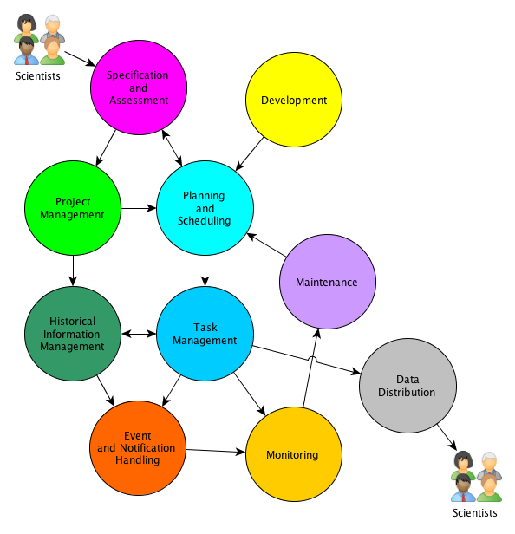Graph 1: Process model (draft)

The general process model is shown in Graph 1. This is a more high level view of the detailed DFDs described in Overeem's document.
The redesign will affect “Specification and Assessment” and “Planning and Scheduling” parts of the process.
These are described in some detail below.

Specification and Assessment

Specification and assessment considers the first steps in the process model. It recieves input from the scientists directly in the form of a science specification and (partial) system specification on how they think the instrument can deliver the data they need.
These proposed specifications are initially stored as draft science and system specifications with a draft project as a container for administration purposes. Together these are called a Proposal.

The proposals received for an observation cycle/semester are then judged on their technical and scientific specifications. At the moment the technical assessment is done by Observatory staff, mostly Science Support, and the science assessment is done by the Program Committee. The purpose of the technical assessment is to ascertain if the proposed system specifications are indeed feasable with the current instrument both at the hardware and software level. If needed the proposed system specifications are adjusted together with the scientist making the proposal. If the result of the technical assessment is then that the draft project is feasable on the technical level, the project is marked as one for scientific assessment.

Based on the proposed system specifications also an initial draft semester planning is made. The draft semester planning together with the technical assessment outcome and the science specifications are then input to judge if the project should be accepted in part or as a whole, depending on the merits of the science, required and available resources and the other proposals.

If a Proposal passes science assessment successfully in part or as a whole it becomes a Project. In principle the science specifications will not need any further updates until the project finishes. The system specifications might still change due to changing capabilities of the instrument or general availabilty and functioning of (parts of) the instrument.

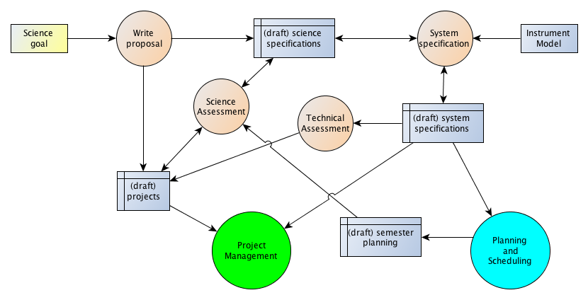Graph 2: Specification and Assessment DFD
The Project itself is no longer managed by the Specification and Assessment systems but ownership is handed over to the Project Management systems, which will track its progress and hopeful successful completion.
The system specifications and semester planning will be further managed by the Planning and Scheduling systems that up to this moment have had a minor role only in supporting the creation of the initial draft semester planning. Project Management itself is not part of this document, but Planning and Scheduling is described in the next paragraph.

Planning and Scheduling

After all projects for a semester have been accepted, the first main task is to take the system specifications of all the individual projects and try to fit them into a semester planning. An initial version of this schedule will usually have been drafted during the assessment process.
This semester planning is a description in some form of all the tasks that need to be performed, with their system specifications, and when and in what order they should be executed.
Software and hardware development, maintenance and system reliability will have a continuous impact on this initial planning. Project Management keeps constant track of the progress of the tasks and as such is also an important feedback mechanism into the semester schedule.
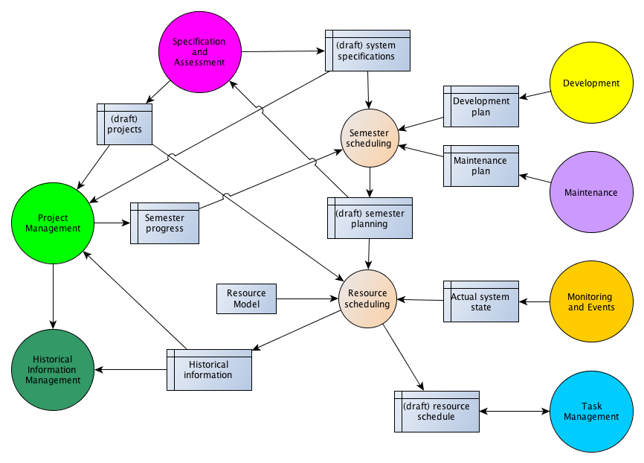Graph 3: Planning and Scheduling DFD
The final step before tasks are transferred to the Task Management systems is to translate the system specifications into detailed resource allocations, depending on the actual system state and the resource model. This creates a resource schedule of individual tasks that also constantly changes as the actual system state and the semester schedule get updated. These tasks and changes to them also get communicated to the project management systems to track their progress. When the tasks become active their ownership is transferred to the Task Management systems and their resource allocations are fixed.
The Task Management systems report back to the Project Management and Historical Information Management, but those processes are also outside the scope of this document.

In the current implementation Project Management and Historical Information Management is mostly handled by MoM, Task Management mostly by SAS/MAC/OTDB, and Monitoring and Events by PVSS and Zabbix. Maintenance and Development has almost no software tooling connected to the system.

Current implementation

The current implementation consists of three main pieces:
- The Northstar and Northstar review tools.
- Tools to create, manage and track individual tasks: XML Generator, MoM, OTDB, Scheduler.
- A large collection of various files, spreadsheets and webpages, which are manually maintained. These function as an intermediary between the first two sets of tools, and fill various gaps that the existing tools don't cover (well).

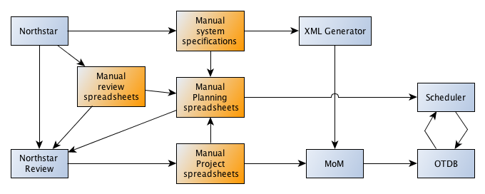Graph 4: Current implementation
Northstar is the application that the scientists use to input their science and system specifications to create a proposal. The technical assessment of these is mainly done using manual spreadsheets for initial semester planning and specifications review.
The proposals in Northstar, together with the manual system specifications and planning review, then serve as input into the scientific review process, which is supported by the Northstar review tool.
The proposals that get accepted into projects then are put manual spreadsheets and transferred into MoM in a semi-manual fashion using various scripts. A large part of the semester progress and project management happens outside of MoM in various spreadsheets and webpages.
The system specifications that the scientist has entered into Northstar are not transferred to MoM at all. They are put into manually generated and maintained files, called parameter files, which are then used as input for the XML generator.
The XML generator creates batches of system specifications at the individual task level in a format that can then be imported into MoM manually, using those manual specification files.
MoM then communicates those system specifications to OTDB, which is the Task Management system. These are then turned into something resembling full resource allocation specifications but with placeholders for a lot of the actual resources. This is then communicated back to MoM for it's Historical Information database role.
The Scheduler is run as a separate process on these placeholder resource allocations, with as input manual information from various planning spreadsheets. The Scheduler then manipulates the placeholder values, replacing them with the actual resource allocations. This is then communicated back to MoM for it's Historical Information database role.

Problems with the current implementation

This is an incomplete overview of some of the main problems with the current implementation that this redesign document hopes to (partially) address.
- The system relies a lot on manually tracking information across various files and spreadsheets.
- Clear interface definitions between the tools are missing or very out of date, making it impossible to automatically exchange information efficiently.
- A lot of poorly designed and maintained scripts exist to process large batches of information to transform it into a certain format so it can be extracted or used as input for one of the tools. Sometimes no other ways exist, or the options that do exist are not designed to cope with the volumes that LOFAR requires.
- Specifications are expanded into fully defined individual tasks in the system early in the process. This makes volumes large and thus manipulation of the data slow. It also makes it hard to track relations between the individual tasks as those are not explicitly coded. This also makes it hard to do manipulations on sets of tasks.
- Because of the batch nature of the tools that exist, and the need to run them manually, it is very hard and slow to make changes and have those propagate through the systems.
- MoM transfers the specifications in a placeholder resource allocation format to OTDB, which is the Task Management system. But after that the Scheduler then operates on these specifications while the Task Management system already has ownership.
- The Scheduler is not a permanently running tool. It requires manual interaction to change anything. This means that the system can't be responsive.
- A lot of the user interfaces that do exist have not been updated in a decade and are using technology that make them hard and/or slow to use.
- A lot of the manual tracking that is done using spreadsheets and scripts which aren't specifically designed for these tasks. This makes it hard to represent the needed information and manually keep the data up-to-date.
- There is almost no tooling support for the system specification assessment and planning steps during the proposal assessment phase.
- The different systems use different terms and use different data models, with no clear translations between them. This requires a lot of expert knowledge to be able to check correctness and make changes in the system. This makes the risk and cost of changes high.

See also the chapter on Further work for other issues outside the scope of this document.

Redesign

Implementation phases

The proposal for a redesign of the system can be split into two main phases:
- Building new tools and extending existing tools, but leaving all the existing functionality intact and operating.
- After all the new tools have been built, the (partial) de-activation of quite a few of the current tools as they become obsolete.

In the graph below the existing tools that were described in the previous chapter have been omitted for clarity, if no changes are proposed to them. The graph shows the overall relations between the new tools to be implemented and the existing tools that will need to be changed. Each tool will be described in detail further below.

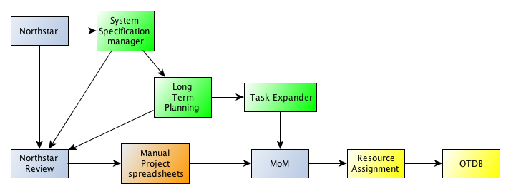Graph 5: Phase 1 A(green) and B(yellow)
The new and changed tools in the graph above can be built in two steps:
- A chain of tools can be created to replace the current manual tools, scripts and procedures to manage the system specifications and long term planning.
- A chain of tools for resource assignment and transfer to Task Management can be created to replace the current tools.
The order between these is somewhat arbitrary, A and B can be implemented largely independently.

The most important thing to note in the graph above, is that Resource Assignment sits between MoM and OTDB, instead of operating on OTDB with MoM talking to OTDB directly. Secondly there is a system to manage System Specifications outside of MoM and Northstar. The Task Expander will have a similar role as the current XML Generator, turning high level specifications and planning into detailed task specifications. Finally there will be some tooling needed to support and store long term planning, which can then be expanded upon later.

When this has been fully implemented and the old tools are no longer needed, then the old tools can be abandoned and the system can be further streamlined by moving the Task Expander to be used after MoM instead of before it, as shown in the graph below.

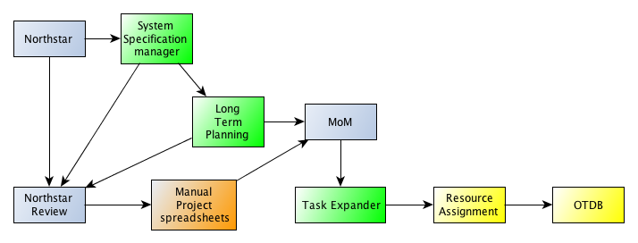Graph 6: Phase 2
It's important to understand these two phases to this redesign to be able to follow the more detailed design description below.

Design

Below is a graph that shows in more detail the tools and data storages that will exist in the new design. Each of these components will be described in some more detail below.
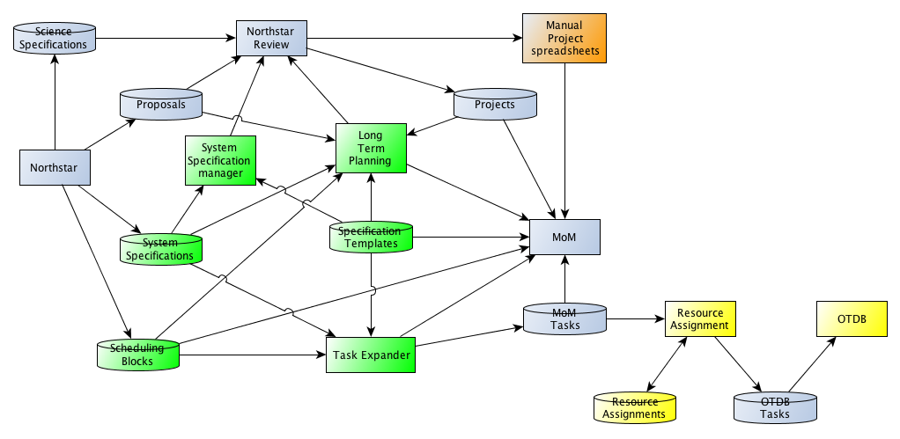Graph 7: Detailed design overview
Before implementation a much more detailed design will be needed, but for initial discussions this should be sufficient. Also the designs will change as result of the discussions.

Specification Templates

These specification templates are a crucial part of the new design. The goal of these is to move the current template mechanism that exists in OTDB to a much higher level and much earlier in the chain.
The specification templates are not just templates for individual tasks as they currently exist in OTDB, but are templates for a full processing chain, from data gathering (observations), data processing (pipelines) to archiving (ingest). These will be created, changed and managed by the System Specification Manager. Smaller templates for single tasks should be able to be combined into larger templates.
These should be viewable and specifiable from Northstar as part of the system specification in the proposal.

System Specifications

System specifications are collections of settings and parameters for one or more tasks together with a selected Specification Template that contains those tasks.

System Specification Manager

The System Specification Manager is a collection of services that are tied closely together into a single tool:
- The Template Manager allow users to create, change and manage Specification Templates.
- The Specification Manager allows users to create, change and manage System specifications.
- The Specification Evaluator is used by the scientist writing the proposal, and the assessment process to validate system specifications and generate estimated resource usage.

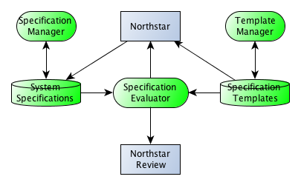Graph 8: System Specification Manager

Scheduling Blocks

Scheduling Blocks are collections of one or more Specification Templates and System Specifications with a defined start time, and speficied numbers on how often the selected Specifications will need to be repeated within the scheduling block. An estimate of the required resources can also be stored with a refence to a scheduling block and updated when it gets changed. One of those will usually be a time duration for use parts of the instrument.

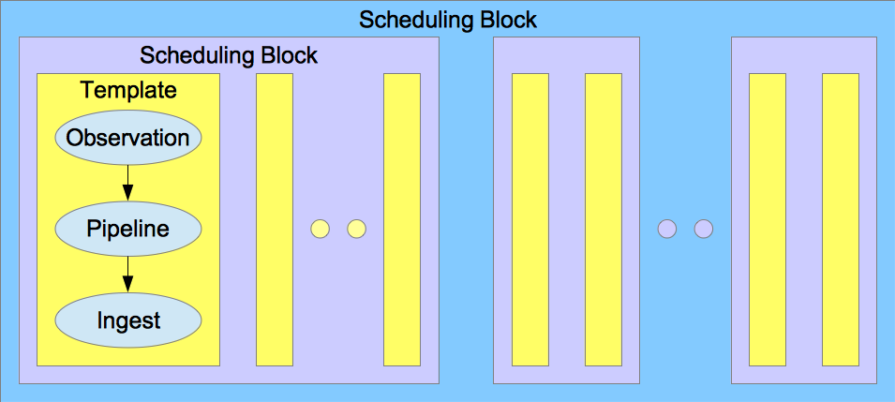Graph 9: Scheduling Blocks
We might need to support not just nesting of Scheduling Blocks, but to allow templates or blocks to be part of multiple higher level blocks that overlap. This might depend on the type of block. Detailed design based on use cases will need to be done to determine what should be needed. In general it would not be hard to design at least the basic data and database models in such a way as to flexibly expand their use in the future beyond a more basic initial implementation.

We can then visualize these blocks in various ways depending on the need. For example, it can be an aid in semester assessment and planning.
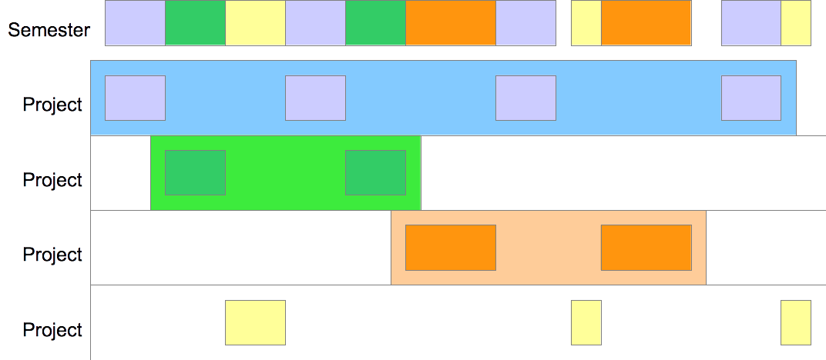Graph 10: Semester Planning
By just showing the lowest level of blocks, it can also be an aid in more detailed scheduling of a single week, like in the example below.
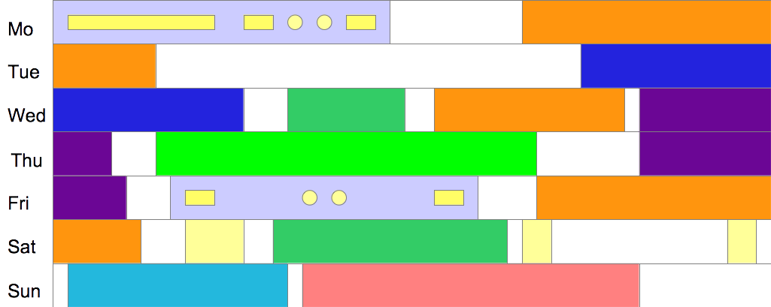Graph 11: Scheduling a week
The task information can also be used to generate a prediction graph of resource usage. This could look something like the example below.
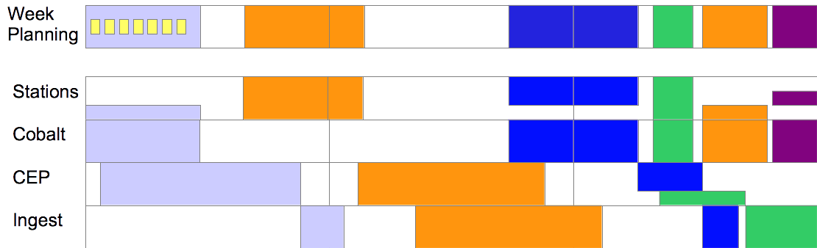Graph 12: Resource usage prediction
It would possible also allow the system to show completeness of the tasks, blocks and projects within the various views with a simple toggle or something like that. An example of what this could look like is shown below.
Parts of this already match current functionality in MoM. This is partially an extension of the current folder concept in MoM.
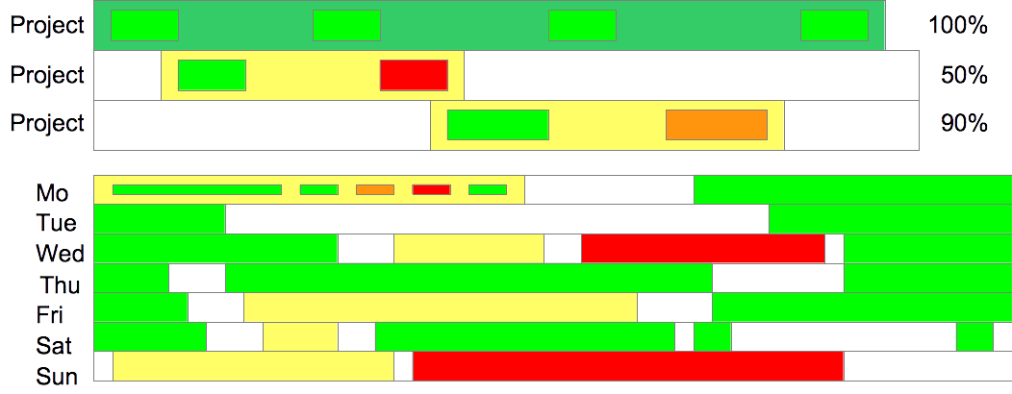Graph 13: Tracking task success at the higher block levels

Long Term Planning

The Long Term Planning tool consists of three main services:
- A Scheduling Block Manager that allows you to create, change and manage Scheduling Blocks.
- A Long Term Scheduler that combines all the Scheduling Blocks into a Long Term Schedule and allows you to manipulate the start times of groups of blocks. It produces a combined view that can be used for the review process and semester planning. This is currently just modelled as a view on the Scheduling Blocks database, but could be stored separately.
- An optional Schedule Optimizer. This would be a tool to automatically optimize the schedule in some form. Implementing this would be a large effort.

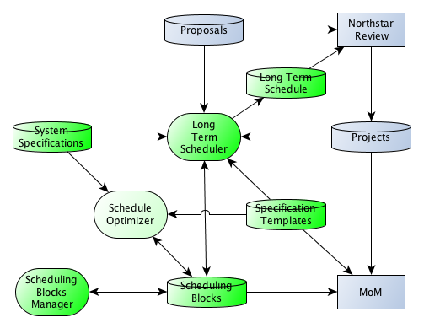Graph 14: Long Term Planning tool

Northstar

This tool allows scientists to enter the draft science and draft system specifications that are connected to a Proposal as well as the proposal information itself. Currently this is all stored in a single “Opticon” database, which probably needs some redesign to separate these more clearly and allow other tools to interact with them as well.

Northstar review

This tool is used during the assessment process. The main change will be that now the automatic evaluation of the system specifications and a draft long term schedule can be used as direct input into those processes.

Proposals

These are basically draft projects and might end up being stored as such in a combined project database, or separately like they are now in Northstar.

Projects

Projects are accepted proposals. They are the intellectual owners of the tasks and the generated dataproducts. These have members, maximum resource allocations set by the review board and other such properties.

Task Expander

The Task Expander is a simple service, similar to the current XML Generator, but then running continuously as a service. It expands the Scheduling Blocks with their associated System Specifications and Specification Templates into a full list of tasks. This includes start times.
This expansion can either be triggered manually or based on the start time of a Scheduling Block approaching. In Phase 1 these will then be stored into the MoM database in a similar fashion as the current output of the XML Generator. After which the old existing tools like MoM and the Scheduler can be used or the new Resource Assignment tool, if that has been implemented.

MoM

MoM will not need to change much in Phase 1A. The Scheduling Blocks and Specification Templates can be shown in the MoM database as folders, and the Projects are currently a part of the MoM database. When the Task Expander is used, then all the folders, measurements and pipelines are stored in MoM, initially through the existing importXML service.
The databases like the one storing the System Specifications and the Scheduling Blocks will need to keep track of with corresponding MoM object they relate to. MoM might need to be aware of this if things get deleted in MoM.
In Phase 1B MoM will need to be aware of the Resource Assignment tool and not transfer tasks handled by that tool into OTDB, but let the new tool do this. The mom-otdb-adapter would no longer be used for this. MoM might also be made more aware of the properties of the Scheduling Blocks and Speficiation Templates.
In Phase 2 the Task Expander can be shifted to work much later in the process basically just before the Resource Assignment happens. This means that in MoM you will mostly see Scheduling Blocks and Speficiation Templates and not individual tasks. This could be used to make the views in MoM a lot lighter and quicker by not having tasks show up in the standard interfaces but only specifically when requested, like currently already happens for the dataproducts of the individual tasks.
Please note that within the scope of this document the exact structure of MoM itself is not discussed but represented as a single entity. In reality it consists of various parts and services. Together those form the custodians of the historical information and project databases besides a lot of other functions less relevant to this document.

Resource Assignment tool

This is a continuously running service that gets the current system state and available resources as input. The goal is to replace the mom-otdb-adapter and the scheduler. It can assign resources to a task as specified in MoM, and then put it into the OTDB database as a fully specified Virtual Instrument.
- This resource assignment can be triggered manually.
- This resource assignment will be done automatically using the system specifications when the start time of a task approaches and the task is enabled/valid/approved.
This tool will also need some form of GUI, partially based on the current Scheduler tool.
It has its own separate database to store the current resource assignments. This is useful to be able to view and edit the assigned resources manually if needed. Some kind of monitoring/viewer tool might be part of this, or separate.

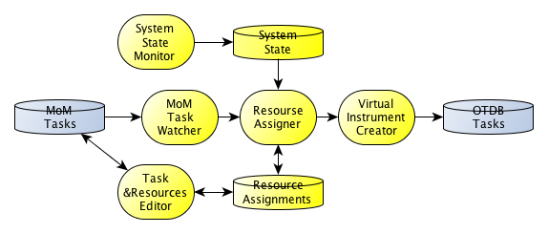Graph 15: Resource Assignment tool

OTDB tasks

These are system tasks with fully specified resources. Within SAS these are known as Virtual Instruments. These are known aslo as scheduled tasks. These are put into the OTDB task database by the Resource Assignment tool.

OTDB

This the tool that SAS and MAC talk to to manage and execute the scheduled tasks as part of Task Management. It probably needs some changes, at least in Phase 2, as the old Scheduler and its interaction with the database will no longer need to be supported.

Technology

As far as which technologies will be used to implement this design there are a few important choices that will need to be made.
- Within the 3R project a choice has been made to use XSD for interface descriptions and XML for the actual data whenever possible. It's probably best to follow that decission when possible.
- Within the 3R project a choice has been made to implement new tooling as services as much as possible. It's probably best to follow that decision when possible.
- Within the 3R project a choice has been made to communicate between services/tools using QPID. It's probably best to follow that decision when possible. When not possible something like XMLRPC over https might be the best option.
- For implementing the new services either Java or C++ can be a suitable option. Maybe a mix will be used. Python might also be an option in some cases.
- For user interfaces either Webinterfaces can be used, or more traditional stand alone applications. We currently have very little experience in the team developing Webinterfaces with modern tools like JSF, Ruby on Rails, etc. There is some experience developing with older Java based frameworks, and with QT.

Results

With this redesign the following results can be achieved:
- A fully integrated and automated information flow from proposal to task execution.
- A resource assignment system that runs in near real time, allowing much better matching of available resources.
- Support for long term planning in the assessment and semester execution.
- Constant and explicit verification of system specifications.
- Management of specification templates, allowing science support direct control.
- A system that actively monitors for changes during each stage of the specification process, allowing it to respond quickly to changes.
- It should make it easier to learn the system as naming and modelling can be made much more consistent.
- Separating the roles of specification, scheduling, , task management, project management and historical information management more clearly into different tools will make the design of each tool clearer and more consistent. In the past with more monolithic tools we've seen that these roles were not always properly separated causing conflicts and user confusion.
The last part is essential to get to a responsive telescope. When this system is fully operational, a change in a scheduling block, either manually, or by an internal or external trigger, will be able to propagate through the system quickly and automatically.

Implementation

This chapter will describe the impact on the tools in some more detail to get a first impression of the implementation tasks that will be needed. This will need to be made more detailed and expanded so it can be turned into a planning. Part of that will happen as this document is discussed and updated.

General

We should try to build initial versions of the tooling described in this document quickly and in a lightweight fashion. Quite a few don't need to be much more than a visual database manipulation tool closely matching the underlying data model and database. This allows to gain some experience with the designs and then update and expand the tooling based on those initial versions.
Preferably we could initially implement a subset of functionality that is not supported by the current system as it offers the immediate reward of additional functionality to the users. Otherwise it can take quite a bit of time to see a return on investment, making it hard to justify the effort.
I do think that it's necessary to spend some time to get a good Virtual Instrument Model to make sure that all software that will be created and/or updated will use a common and consistent model. This then helps in creating clear interfaces between the various tools as well, including existing tools. For example, we can have an updated Virtual Instrument Model, and then translate it into the current model in OTDB in a clear and future proof way.
It will be important to keep the interactive nature of the current Scheduler as this is appreciated by the current users. Preferably any new tools should have a similar or better performance. High interactivity can conflict with trying to manipulate databases directly instead of manipulating the data in memory and doing a separate sync like in the current Scheduler. If multiple users can change resource assignments and specifications at the same time, this will complicate matters as other users need to be made aware of those. This means that there are some conflicting requirements between performance and consistency. We hope that tools like a messaging bus can help here, but depending on the chosen technology it will not be the complete solution.

Northstar

Northstar will need the following changes:
- The part of the proposal connected to the user and project administration will only need to have an interface that exposes the proposals to the other tools but can otherwise remain unchanged.
- The part of the proposal that handles the science can also remain largely unchanged. It might need to be somewhat more separated from the system specifications.
- The part where the system specifications for the proposal are entered and administered will need large changes. It will need to be able to specify Scheduling Blocks and Specification Templates (more on this later) and have an interface to expose those to the other tools.
- It needs an interface to the System Specification Manager for validating the specifications.

Northstar review

Northstar Review will need the following changes:
- It should have a way to read the evaluations of the system specifications.
- It should have a way to interface with the Long Term Planning tool.

System Specification Manager

This will need to be built from scratch. It should start with a data model of system specifications and templates. The current Northstar, XML Generator and MoM functionality can be used as input for the design.

Long Term Planning

This will need to be built from scratch. The current Google spreadsheet can provide some input to the design. It should be more elaborate and include explicit views on the compute use, storage use, archiving and other resources that the tasks need.

Task Expander

This will need to be built from scratch or be an evolution of the parameter generator scripts (by Wilfred?) and the XML Generator. It should eventually also include things like GenValOps.

MoM

MoM will need extensive changes.
- It will no longer need its current specification tools. Changes should be done in the System Specification Manager and/or Templates.
- It will need to be able to understand Scheduling Blocks and Specification Templates, initially just as folders, but it will need a more extensive rework.
- The UI will need some redesign to be able to show and visualize the changes in the rest of the system.

Resource Assignment

This will need to be rebuilt from scratch. The current Scheduler algorithms can be used as input into the design. Probably the Resource Assignment Viewer/Editor can re-use large parts of the current GUI.

OTDB

OTDB will need to change to accept new parameters that are needed to track the various component relations to the tasks and in Phase 2 it will no longer need to support the old Scheduler, which possibly means that a state like PRESCHEDULED is no longer needed.

Further work

For responsive telescope more will be needed than to be able to quickly change specifications and schedules of tasks, which is the scope of this document. We probably will also need to be able to interrupt already running tasks. This would require changes in parts of the Task Management, mostly SAS/MAC/OTDB. The changes in the specification and scheduling systems would be minimal, if this is already kept in mind when doing the detailed design.

It might also be possible to simplify the current SAS/MAC/OTDB after the OTDB is no longer needed by the Scheduler. Some other states in use by the MACScheduler might also be redundant.

Currently a Generic pipeline framework is also being investigated/developed. The need to specify pipelines in such a framework will have influences on specification and scheduling as well.

Currently there is also a large mismatch between the various Virtual Instrument Models in tools like MoM, OTDB, Northstar, LTA and Scheduler. It has also been identified that none of these match the current capabilities of the hardware very well. Making those models align much more with each other and the hardware will be a need to address in the future as well.

To fully support the workflow/processes as currently used/done in the observatory, some additional processes might need to be modelled in the software. For example we might need manual inspection of data to be explicitly modelled. This might be needed to properly define templates to include such a step.

A large redesign of MoM, particularly the visualization part that generates the webpages might be in order in the future, especially if it keeps being the main tool for Project Management and Historical Information Management. Examining what is and will be needed for those is outside the scope of this document, and as such the choice was made to keep MoM at least in those roles.

A lot of the current interfaces mix a lot of different functionality. For example, the parset contains both resource assignments, but also configuration and communication fields. This is an unwanted mix of purpose and causes unneeded overhead as the configuration will be static and independent of the task to be executed. Other parts of the configuration are distributed through scripts, Jenkins, svn and other means, even manual input. A lot of these would benefit from a few simple databases. Initially these can be filled manually, like the configuration is often done now, but preferably they would be automatically updated from the monitoring systems. For example which stations talk to which Cobalt nodes, locations of the stations, available storage systems, etc.

The current user management is very closely tied into the MoM application, although it's also used by Northstar. There is also IDM which is only used by the LTA. It might need some redesign or updating as well, especially because security concepts have changed over the past 15 years, but also because there are now large international options available that might provide a better user experience and share the costs of development.

Project management support and semester tracking is currently only partially implemented in the tools (mainly MoM) and basically not used. Some progress has been made here with the “birt views”. Better support would increase insight and reduce the workload.

Appendix A: Glossary of terms

I see several terms that are causing a lot of confusion in the discussions. Below I will try to explain my view on several of these and how I use them in this document.

Proposal

The proposal means the administrative unit that is the owner of a set of science and system specifications, and also often refers to the collection as a whole.

Specifications

Currently this is a very much overloaded term. There are at least 6 places in the LOFAR system where “specification” happens: Northstar, XML generator, MoM, OTDB templates, OTB, Scheduler. As far as I am concerned a lot of our current problems stem from this scattered and inconsistent approach. Secondly, it's currently mixed with all kinds of other tasks like project management.
I currently see 3 distinct types of specifications. I think that making clear distinctions between these types in the various tools can greatly improve clarity and speed of the various specification steps and user interfaces dealing with them.
I only describe active specifications here, those which usually are generated by user actions. You could also identify things that look like specifications but are passive, for example metadata descriptions of data, which would be automatically generated.

Science specification

This is the main domain of the scientist. The scientist has a certain goal in mind and needs to measure certain physics to obtain that goal. A science specification would thus be defined in physical quantities. This would be in terms of frequency ranges, UV coverage, sensitivity, dynamic range, resolutions in time/frequency/space, quality of signal w.r.t. RFI/noise/completeness, field of view, etc.
I can see the scientist specifying a range or minimal, adequate and good criteria. This is separate from the description of the science goal to be obtained. The science goal and science specification would be the main input for the Programme Committee, together with an assessment by the TAC of the system specification (see below).
A full science specification should give you a description of what the system is required to do in physics terms to achieve the defined science goals.

System specification

The system specification is how the criteria in the science specification can be achieved with the LOFAR instrument. It translates frequencies into Subbands and system clock settings, quality requirements into specific observations/pipelines, durations and scheduling requirements, resolution requirements into settings for online and offline processing pipelines, minimum baseline length, sensitivity into numbers of stations, and other LOFAR system specifics, like antennaset selection, etc.
This can then be used for such tasks as long term scheduling, determining required data storage, networking and processing needs, and would be the main input into the assessment by the TAC.
A full system specification shoud give you a description of how the system is going to achieve the science, without any specific identification of hardware components.

Resources specification

Resource assignment is the translation of the system specification into a direct and detailed hardware description that the control systems can use to configure and run the data taking and processing tasks. Examples would be the translation of Subbands into dataslots, subarray pointings into stations beams, stations and antennafield requirements into specific station and antennafield selections, online and offline processing and storage elements (cobalt/locus nodes), etc.
A full resource specification should give you a description of what each hardware component in the system will do to add up to the system specification.

DataProduct/Dataset

To me a dataproduct is the smallest fully selfdescribed unit of data that would make sense and be useful to the scientist. A dataset is a collection of dataproducts, often needed to achieve a certain science goal, but often also just a logical administrative unit.

Observation/Process/task

The term Observation is currently overloaded as it is used in parts of the system purely for the initial data taking process, but in other parts of the system it can mean any type of process/task run by the system. It is also the single undividable unit in which resources specifications are communicated to and used by the system as a whole, with the different subsystems interpreting and translating parts of it as needed.I will mainly use virtual Instrument to describe the latter.
I would subdivide the processes into the following categories, as parts of the system already do/ Each of these in general need resources in the system and they should be explicitly assigned if possible.
I use Task/Process somewhat interchangeably. In general a process is the execution of a task.

Observations

These are the main data taking processes, using the instrument to measure physical quantities and do the required real-time processing to be able to store them in a form that will be useful to the scientist and further processing. For this it's needed that not just the actual “raw data” is stored but also a lot of (meta) data about the state of the instrument and environment when the data was taken.

Pipelines

Pipelines are processes that do further manipulation of the data based upon scientific algorithms. They have raw or processed data as input and processed data as output. Input and output data can also be something like an image, sky model, instrument model, pulsar profile, etc.

System tasks

System tasks are processes that manipulate data on the system for logistical reasons instead of scientific reasons. These are often processes that move, copy or delete data. Examples are ingest, staging, cleanup, etc.

Maintenance tasks

These are processes where part of the hardware of the system is not available for regular operations. Usually this will be for hardware maintenance, software changes, etc.

Monitoring

Monitoring is the automated or manual observation of the state of parts of the system. The goal is to intervene manually or automatically in the tasks/processes if these run into problems, the state of the system changes or the operational needs and priorities change.

Scheduling blocks/folders

Several systems identify a collection of observations/processes/dataproducts/datasets, either called folder or scheduling block. I feel that we need to discern between three types as they function on different levels of specification.
- Science block. This would be a collection of processes and data required to achieve a science goal. For example all processes and data connected to a specific celestial target.
- System block. This would be a collection of processes and data where the specific subdivision is the product of the translation of science into system specifications. For example the slices of MSSS or separate Calibrator/Target observations and pipelines. This might end up being implemented as a Template?
- Management block. This would be a collection of system and science blocks for high level scheduling and management purposes, like all all observations in a certain weekend, or all successful observations.
As far as I'm concerned these shouldn't be purely nested blocks/folders like they are now in MoM. They are collections on different levels of abstraction, and should be able to overlap so that you can either select a M51 collection or a weekend17-18Febr collection.
You could even make these dynamic, like “all finished pipelines” could be a Management Block with dynamic content. They could be like collections of saved queries or views.

Data/Metadata

In the case of LOFAR our main product is science data of various types. This is stored in dataproducts. It consists of two types:
- Data: This is the “raw data”: The observed physical quantities that the scientist needs to interpret and process to do science. Usually this is the bulk of the dataproduct.
- Metadata: Metadata is the data that is needed for the scientist and the tooling to interpret the data. After full scientific processing this can actually be the largest part of a dataproduct.

Virtual Instrument Model

The Virtual Instrument Model is the model of the instrument in software. It is the software description of how the various pieces of hardware can and need to be controlled to produce the desired scientific data.

Virtual Instrument

A Virtual Instrument is a collection of hardware and software settings that together allow the the system to perform a specific task. This is a combination of the system specifications and the resource assignment.

Project Management

Project Management is responsible for:
- Tracking the ownership of data and tasks.
- Access rights and roles.
- Processing the Historical Information to show semester progress.
- Tracking and controlling the overal observatory processes.

Historical Information Management

Historical Information Management tracks the history of all tasks/processes and data(products) in the system. It might also track some general system information, like system health. This is then used to generate reports and as input for further decision making, mainly for Project Management as described above.

Task Management

Task Management translates Virtual Instruments into commands to the actual physical instruments and software and then executes and monitors the system. It reports on the current state of tasks and changes to those.

Appendix B: Information on Virtual Instrument Model

TBD. Input from the current OTDB, Northstar, LTA, MoM, parameter files, parsets for Cobalt and other parts of the system. Several of these have been collected already, but not put into a consistent form yet.
Some initial notes:
- Station settings should be separate from online processing settings.
- All hardware modes should be specifiable.
- TBB needs to be supported.
- Subsets of RCUs need to be specifiable within a station.
- We need to be able to create SAPs/beams/pointings in offline processing.

Appendix C: Planning

A fully detailed planning can not be given at this point but an attempt will be made here to estimate the work needed to design and implement the parts of this plan at a high level. This can not be more than a guess in most cases as detailed design will need to be done.

Task |  | Time
Virtual Instrument Model
 | Design | 2 weeks
 | Update Northstar | 1 week
 | Update MoM | 2 weeks
 | Update OTDB | 2 weeks
Prototyping
 | Technology prototypes | 2 weeks
 | Tool prototypes | 2 weeks
Resource Assignment
 | Resource Assigner + DB | 2 months
 | MoM watcher | 2 weeks
 | Resource Assignment Editor | 2 months
 | Virtual Instrument Creator | 1 month
 | System State Monitor | 1 month
 | Changes in MoM | 2 weeks
 | Changes in OTDB | 2 weeks
System Specifications
 | Specification Manager + DB | 2 months
 | Template Manager + DB | 2 months
 | Specification Evaluator | 2 months
 | Changes in MoM | 2 weeks
 | Changes in Northstar | 1 month
Long Term Scheduling
 | Scheduling Blocks Manager + DB | 2 months
 | Long Term Planner + DB | 2 months
 | Changes in Northstar | 2 weeks
 | Changes in MoM | 1 month
 | Automatic planner | 6 months
Testing and integration
 | various | 4 months?
Total |  | About 32 months

These estimates do not mean that partial functionality can't be delivered in less time. For example, only providing minimal TBB support with semi-prototypes might only require part of the estimated time.
These estimates are also to the point of a first operational version. Further expansion of functionality when such an initial version is in use, can easily lead up to doubling the amount of investment.

